I am imaging the page to be a tricky one. Since the JavaScript is able to read, and even change the user’s choice and other data, it may be fun to play with it. for instance, I can set up a radio form asking who is the user’s favorite singer, and whoever they chose, the feedback from the website may be “Wrong! It should be another one!” or if the user chooses A, the feedback will be “I am so sorry for you that you even like B’s work.” 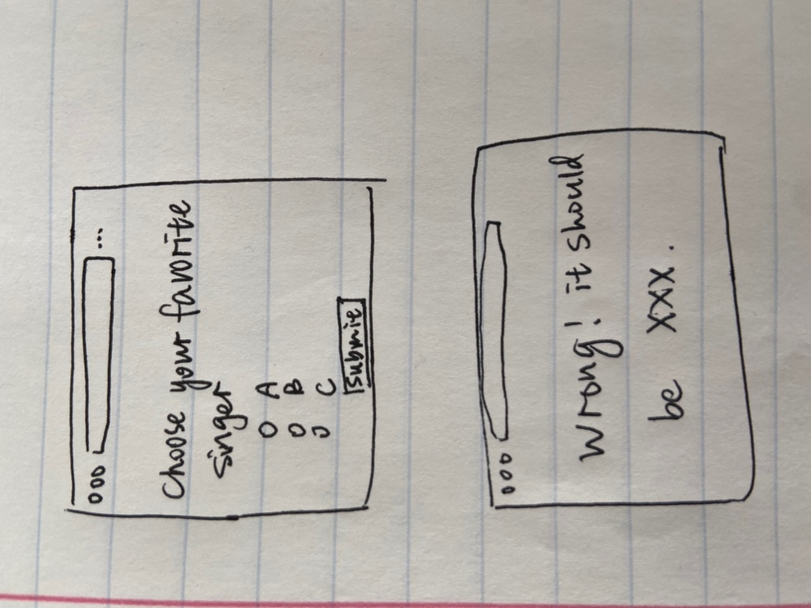

By doing so, somehow I give the website a dicky personality.